1. 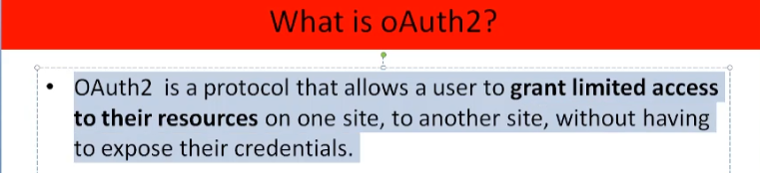
2. **For Example**:
   1. There are many resource servers such as one to expose Photos, another to expose Docs, still another to expose emails etc.
   2. Our resources are exposed by API.
   3. We’re the resource owner.
3. 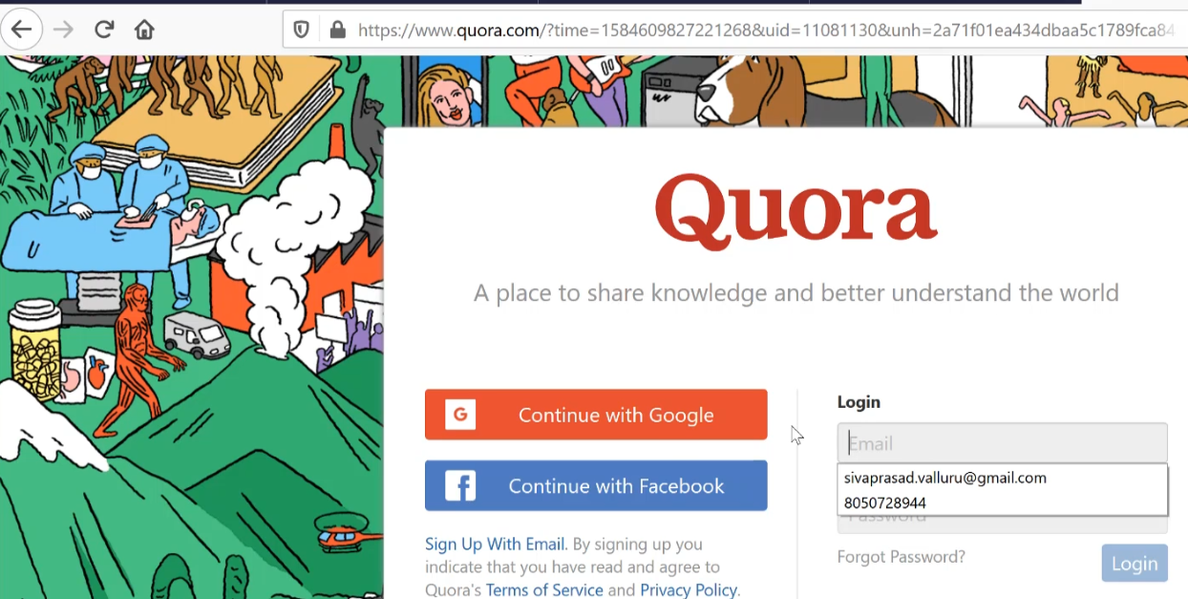 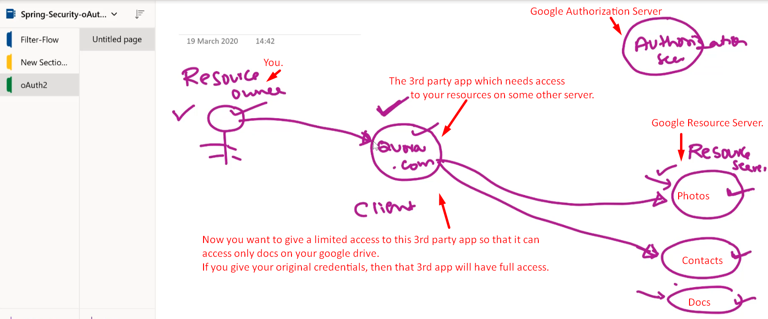
4. Let’s see the various ways a resource owner (user) can grant access to his resource to a client.
5. **Grant Types**:
   1. Authorization Code Grant.
   2. Client Credential Grant Type
   3. Resource Owner password Grant Type.
   4. Implicit Grant.
6. **Authorization Code Grant**:
   1. Actually, in Oauth, there are 4 actors.
      1. Resource Owner (User).
      2. Client (App) wanting to access user’s resource.
      3. Resource Server.
      4. Authorization Server.
   2. 